

**A PROJECT REPORT ON**

**Vizpro Insights Hub**

**Submitted by:**

**Chandrashekhar Sharma (2819)**

UNDER THE GUIDEANCE OF

# Mrs. Manpreet Hire

Submitted in partial fulfilment of the requirements for qualifying

## BACHELOR OF SCIENCE IN DATA SCIENCE 2024-25

Semester V - Examination

## 

## THAKUR COLLEGE OF SCIENCE AND COMMERCE

Thakur Village, Kandivali (E). Mumbai - 400101

PROJECT CERTIFICATE

This is to certify that the project entitled, “**Vizpro Insights Hub”**, undertaken at “Thakur College of Science and Commerce”, is Bonafide work of **MS. CHANDRASHEKHAR SHARMA** bearing Roll. No. 2819 submitted in partial fulfilment of the requirements for the award of degree of BACHELOR OF SCIENCE IN DATA SCIENCE

(**Semester VI**) in the academic year **2024-2025**.

It further certifies that we have partially completed all the required phases of the project.

**Signature of Internal Examiner Signature of External Examiner**

**Signature of Project Guide Signature of H.O.D**

College Seal

**Acknowledgement**

We would like to express our heartfelt gratitude to our Project Guide “**Mrs. Manpreet Hire”** and Head of Department “**Dr. S. K Singh”**. Their unwavering support and guidance have been instrumental in our successful completion of the project on **'Vizpro Insights Hub.**' Their trust in our abilities and the opportunities they provided allowed us to embark on this enriching journey. With their mentorship, we conducted extensive research, expanding our knowledge and skills in the process. Their vision and support granted us the golden opportunity to explore the world of **'VIZPRO INSIGHTS HUBS'**. Their encouragement and guidance enriched our understanding of the subject matter and allowed us to discover a multitude of new concepts We are truly thankful for their invaluable contributions to our project."

“We extend our sincere thanks to our principal, “**Dr. (Mrs.) Chaitali Chakraborty”**, who played a crucial role in making this project a reality, by giving us a platform to express our perspectives and ideas. We express our gratitude for her indispensable contributions.”

# DECLARATION

We hereby declare that the project entitled, “**VIZPRO INSIGHTS HUB**” is done at **Thakur College of Science and Commerce**, this written submission represents our ideas in our own words and where others' ideas or words have been included, we have adequately cited and referenced the original sources. We also declare that We have adhered to all principles of academic honesty and integrity and have not misrepresented or fabricated or falsified any idea/data/fact/source in my submission. We understand that any violation of the above will be cause for disciplinary action by the Institute and can also evoke penal action from the sources which have thus not been properly cited or from whom proper permission has not been taken when needed.

Date:

Signature

|  |
| --- |
| **Table of Contents** |
| **1.Introduction** |
| 1.1. Purpose |
| 1.2. Scope |
| 1.3. Definitions, Acronyms, and Abbreviations |
| **2.Overall Description** |
| 2.1. Product Perspective |
| 2.2. Product Features |
| 2.3. User Classes and Characteristics |
| **3.Specific Requirements** |
| 3.1. External Interfaces |
| 3.2. User Interfaces |
| 3.3. Software Interfaces |
| 3.4. Communication Interfaces |
| **4.Functional Requirements** |
| 4.1. Data Integration |
| 4.2. Visualization Creation |
| 4.3. User Interaction |
| 4.4. Collaboration |
| 4.5. Customization |
| 4.6. Performance Requirements |
| **5.Non-Functional Requirements** |
| 5.1. Usability |
| 5.2. Security |
| 5.3. Reliability |
| **6.Constraints** |
| 6.1. Technology Constraints |
| 6.2. Regulatory Compliance |
| **7.Entity-Relationship (ER) Diagram** |
| * Class Diagram |
| * Use Case Diagram |
| **8.Data Flow Diagrams (DFDs) at Different Levels** |
| 8.1. Level 0 DFD |
| 8.2. Level 1 DFDs |
| 8.3. Level 2 DFDs |
| **9.Partial Implementation** |
| * VizPro App |
| * Chrome Extension |
| * Website Overview |
| **10.Sign-off** |
|  |

**INTRODUCTION**

**Introduction to Vizpro: A Comprehensive Data Visualization Dashboard**

**Vizpro** is a powerful and versatile data visualization dashboard designed to empower users with intuitive tools for analysing complex datasets. It offers a comprehensive suite of features, including seamless data integration, a wide range of visualization options, interactive exploration capabilities, collaborative features, and extensive customization options. Vizpro is tailored to meet the diverse needs of users, from data analysts to business professionals, providing a valuable platform for uncovering insights and making data-driven decisions.

**Key Features and Benefits:**

* **Intuitive Interface:** Vizpro boasts a user-friendly interface that is easy to navigate, even for those without extensive technical expertise. The drag-and-drop functionality and clear labelling ensure a seamless user experience.
* **Comprehensive Visualization Options:** Create a variety of visualizations, including charts, graphs, maps, and more, to effectively communicate complex data. Vizpro offers a wide range of customization options to tailor visualizations to specific needs and preferences.
* **Seamless Data Integration:** Connect to diverse data sources, such as databases, CSV files, and APIs, to easily import and analyse data from various sources. Vipra’s data integration capabilities streamline the process of gathering and preparing data for visualization.
* **Interactive Exploration:** Explore data in-depth with interactive elements within visualizations. Filter, sort, and drill down into data to uncover hidden patterns and trends.
* **Collaboration:** Share dashboards and visualizations with team members for collaborative analysis and decision-making. Facilitate discussions, provide feedback, and work together to derive valuable insights.
* **Customization:** Tailor Vizpro to your specific needs by customizing the appearance and behaviour of visualizations. Adjust colours, fonts, labels, and data mappings to create visualizations that align with your branding and preferences.
* **Scalability:** Handle large datasets and complex visualizations with ease. Vizpro is designed to scale efficiently, ensuring optimal performance even as data volumes and user loads increase.
* **Reliability:** Count on Vizpro for consistent and reliable performance. The system is built with fault tolerance, error handling, and disaster recovery mechanisms to minimize downtime and ensure data integrity.
* **Security:** Protect sensitive data with robust security measures, including encryption, authentication, and authorization controls. Vizpro adheres to data privacy regulations to safeguard user information.
* **Maintainability:** Benefit from a well-structured and maintainable system. Vizpro is designed for easy updates, modifications, and future enhancements.

**In summary, Vizpro is a comprehensive data visualization dashboard that empowers users to:**

* **Analyse complex data:** Uncover insights and trends hidden within data.
* **Communicate effectively:** Create visually appealing and informative visualizations.
* **Collaborate with teams:** Work together to analyse data and make informed decisions.
* **Customize to preferences:** Tailor Vizpro to specific needs and preferences.
* **Ensure data security:** Protect sensitive data with robust security measures.

**Objectives of Vizpro**

Vizpro aims to achieve the following objectives:

* **Empower users with intuitive data visualization tools:** Provide a user-friendly platform that enables users of all technical backgrounds to create and explore visualizations easily.
* **Facilitate data-driven decision-making:** Offer a comprehensive set of features for analysing complex data and extracting meaningful insights.
* **Enhance collaboration and teamwork:** Foster collaboration among users by enabling them to share, discuss, and analyse data together.
* **Deliver a scalable and reliable solution:** Ensure that Vizpro can handle increasing data volumes and user loads while maintaining high performance and availability.
* **Protect data security and privacy:** Implement robust security measures to safeguard sensitive data and comply with relevant regulations.
* **Provide a customizable platform:** Allow users to tailor Vizpro to their specific needs and preferences, ensuring a personalized experience.
* **Foster innovation and exploration:** Encourage users to experiment with different visualization techniques and uncover new insights.

By achieving these objectives, Vizpro seeks to become a valuable tool for businesses and organizations of all sizes, helping them to make informed decisions, improve efficiency, and drive innovation.

**Scope of Vizpro**

Vizpro is designed to provide a comprehensive data visualization platform that encompasses the following key areas:

**Data Integration:**

* Connect to a variety of data sources, including databases, CSV files, and APIs.
* Support different data formats and structures.
* Ensure seamless data integration and mapping.

**Visualization Creation:**

* Offer a wide range of visualization types, such as charts, graphs, maps, and dashboards.
* Provide an intuitive interface for creating and customizing visualizations.
* Support interactive elements within visualizations for in-depth exploration.

**User Interaction:**

* Enable users to interact with visualizations to explore data, filter, sort, and drill down into specific details.
* Provide intuitive navigation and controls for easy interaction.

**Collaboration:**

* Allow users to share dashboards and visualizations with team members for collaborative analysis and decision-making.
* Facilitate communication and discussion around data insights.

**Customization:**

* Enable users to customize the appearance and behaviour of visualizations to suit their specific needs and preferences.
* Offer flexibility in terms of colours, fonts, labels, data mappings, and calculations.

**Performance and Scalability:**

* Ensure efficient performance, even when handling large datasets and complex visualizations.
* Design the system to scale gracefully as data volumes and user loads increase.

**Security and Privacy**

* Implement robust security measures to protect sensitive data, including encryption, authentication, and authorization controls.

**Maintainability:**

* Design the system for easy maintenance and updates.
* Use a modular architecture to facilitate changes and enhancements.
* Provide comprehensive documentation for developers and administrators**.**

**While Vizpro will focus on these core areas, its scope may evolve based on user feedback, technological advancements, and changing market requirements.**

**2. Overall Description**

* Product Perspective

Vizpro will be a standalone data visualization dashboard, interacting with various data sources, databases, and external APIs. It will provide a user-friendly interface for creating, customizing, and sharing visualizations.

* **Proposed Dashboard Tool: DataViz Pro**
* **Overview:** DataViz Pro is a comprehensive data visualization and analytics platform designed to meet the diverse needs of data analysts, business users, and administrators. It offers a user-friendly interface, powerful data integration capabilities, and a wide range of visualization options to empower users in making data-driven decisions.
* **Key Features:**
* **Data Integration**
* **Versatile Connectivity:** Connect to various data sources, including databases (SQL, NoSQL), CSV files, and APIs.
* **Data Cleaning and Transformation:** Preprocess data to ensure accuracy and consistency before visualization.
* **Scheduled Data Refresh:** Automatically update dashboards with fresh data at regular intervals.
* **Visualization Creation**
* **Drag-and-Drop Interface:** Easily create visualizations (charts, graphs, maps) without extensive technical knowledge.
* **Rich Visualization Library:** Choose from a wide range of visualization types to suit different data analysis needs.
* **Customization Options:** Tailor the appearance of visualizations to match branding or preferences.
* **User Interaction**
* **Interactive Elements:** Incorporate interactive elements like drill-down, filtering, and zooming for deeper analysis.
* **Customizable Dashboards:** Create personalized dashboards to focus on relevant metrics and insights.
* **Real-time Updates:** Visualize data in real-time to monitor trends and make timely decisions.
* **Collaboration**
* **Shared Dashboards:** Share dashboards with team members for collaborative decision-making.
* **Permission-Based Access:** Control who can view, edit, and share dashboards.
* **Version Control:** Track changes to dashboards and revert to previous versions if needed.
* **Customization**
* **Theme Customization:** Change the overall appearance of the tool to match corporate branding.
* **Custom Widgets:** Develop custom widgets to extend the functionality of the platform.
* **Integration with Other Tools:** Integrate with other business applications for seamless workflow.
* **User Classes and Characteristics:**
* **Data Analysts:** Leverage DataViz Pro to analyse complex data sets, identify trends, and uncover insights.
* **Business Users:** Benefit from the user-friendly interface to gain valuable insights without extensive technical expertise.
* **Administrators:** Manage data sources, user permissions, and system settings to ensure optimal performance.
* **Benefits of DataViz Pro:**
* **Improved Decision Making:** Make data-driven decisions based on accurate and insightful visualizations.
* **Enhanced Collaboration:** Foster teamwork and knowledge sharing through shared dashboards.
* **Increased Efficiency:** Streamline data analysis processes and save time.
* **Scalability:** Handle large datasets and growing user needs.
* **Customization:** Tailor the tool to specific requirements and workflows.
* Product Features
* Data Integration: Connect with diverse data sources including databases, CSV files, and APIs.
* Visualization Creation: Enable users to create a variety of visualizations (charts, graphs, maps) using a drag-and-drop interface.
* User Interaction: Support for interactive elements within visualizations for in-depth analysis.
* Collaboration: Share dashboards and visualizations with team members for collaborative decision-making.
* Customization: Allow users to customize the appearance and behaviour of visualizations.
* User Classes and Characteristics
* Data Analysts: Users responsible for analysing and interpreting data.
* Business Users: Users from non-technical backgrounds who need insights from data.
* Administrators: System administrators responsible for managing data sources and user access.

**3. Specific Requirements**

* External Interfaces

External interfaces are the connections and interactions between a software system and external entities, such as other systems, third-party services, or hardware devices. These interfaces define the methods, protocols, formats, and rules for exchanging data, executing transactions, or initiating communication with these external entities.

* User Interfaces

User interfaces are the components of a software system that allow users to interact with the system. They include the graphical user interface (GUI), command-line interface (CLI), and other forms of interaction. User interface requirements specify the design, functionality, and behaviour of these interfaces to ensure a user-friendly and efficient experience.

* Software Interfaces

Software interfaces are the connections and interactions between different software components or systems. They define the methods, protocols, and formats for exchanging data, executing transactions, or initiating communication between these components or systems. Software interface requirements specify the functionality, behaviour, and compatibility of these interfaces to ensure seamless integration and interoperability.

* Communication Interfaces

Communication interfaces are the connections and interactions between a software system and external communication channels, such as networks, protocols, or data transfer mechanisms. They define the methods, protocols, and formats for exchanging data, executing transactions, or initiating communication between the software system and these external communication channels. Communication interface requirements specify the functionality, behaviour, and compatibility of these interfaces to ensure efficient and secure communication.

**3. Functional Requirements**

* Data Integration: Vipra’s data integration functionality serves as the backbone of the platform, enabling users to seamlessly connect with diverse data sources. Leveraging a user-friendly interface, users can effortlessly link Vizpro to databases, CSV files, and APIs. This integration process is designed to be intuitive, eliminating the need for extensive technical knowledge or complex setup procedures. By providing a smooth data connection experience, Vizpro empowers users to access the information they need for visualization and analysis, enhancing productivity and decision-making capabilities.
* Data Mapping: This involves analysing and documenting the attributes of each system that will be integrated. The output of this process is a Data Mapping document, which serves as a guiding document for the development team. It is important to understand the mandatory attributes of each system and ensure they are mapped appropriately to avoid errors.
* Data Model Relationship: Understanding the relationship between the data models of the integrated systems is crucial. This includes identifying whether the data relationship is one-to-one, one-to-many, or many-to-many.
* Linking Data Element: A unique linking data element, such as an Employee ID, is necessary to transfer information between systems. In some cases, more than one unique element may be required to form a unique combination.
* Data Volume and Movement: Understanding the types and volume of data, as well as its movement within the firm, is essential for capturing all the necessary data integration requirements.
* Business Processes and Data Volumes: Examining the business processes and data volumes is necessary to determine whether the existing processes meet or impede the ecosystem. This includes exploring upstream and downstream capabilities to ensure the proposed integration is efficient and effective.
* Visualization Creation: Vizpro offers a comprehensive suite of visualization creation tools tailored to meet the diverse needs of users. With a drag-and-drop interface and an extensive library of charts, graphs, and maps, users can easily craft compelling visualizations that effectively convey insights from their data. The platform prioritizes flexibility and customization, allowing users to fine-tune visualizations to align with their specific requirements and preferences. Whether creating simple line charts or complex heatmaps, Vizpro empowers users to unlock the full potential of their data through visually engaging presentations.
* Data Visualization Requirements: Defining the requirements for data visualization involves understanding the data sources, business needs, data quality, and integration methods. This includes identifying the expected outcomes, benefits, and metrics of data visualization, as well as the stakeholders, users, and roles involved.
* User Interaction: Vizpro's user interaction features elevate data exploration to new heights, fostering a dynamic and engaging user experience. Through interactive elements embedded within visualizations, users can delve deeper into their data, uncovering patterns and trends with ease. Advanced functionalities such as filtering, sorting, and drill-down capabilities enable users to manipulate data on the fly, facilitating rapid insights generation. By placing interactivity at the forefront, Vizpro empowers users to interact with their data in meaningful ways, driving deeper understanding and informed decision-making.
* User Interface Requirements: Defining the requirements for the user interface involves understanding the user's needs, preferences, and expectations. This includes designing an intuitive and user-friendly interface that meets the user's requirements and enhances their experience.
* Collaboration Requirements: Defining the requirements for collaboration involves understanding the needs and expectations of the stakeholders involved. This includes identifying the tools, platforms, and processes that will enable effective collaboration and communication among the stakeholders.
* Customization: Users should have the ability to customize the appearance and behaviour of visualizations to suit their specific requirements. Customization options may include adjusting colours, fonts, labels, and other stylistic elements, as well as defining custom data mappings and calculations.
* Customization Requirements: Defining the requirements for customization involves understanding the user's needs and preferences. This includes designing a system that can be tailored to meet the user's specific requirements and preferences, ensuring a personalized experience.
* Performance Requirements
* Performance Requirements: Defining the performance requirements involves understanding the system's expected performance levels, such as response time, load capacity, and scalability. This includes identifying the tools, processes, and resources necessary to ensure the system performs optimally and meets the user's expectations.

**4. Non-Functional Requirements**

* Usability:
* Usability focuses on the ease of use and understandability of the dashboard for end-users. In Vizpro, usability considerations include:
* Intuitive User Interface: Designing a user interface that is intuitive and easy to navigate, with clear labels, consistent layout, and familiar interaction patterns.
* Accessibility: Ensuring that the dashboard is accessible to users with disabilities by adhering to accessibility standards and guidelines, such as WCAG (Web Content Accessibility Guidelines).
* User Training and Onboarding: Providing user training materials, tutorials, and onboarding processes to help users learn how to use the dashboard effectively and efficiently.
* Security
* Security requirements focus on protecting the confidentiality, integrity, and availability of data within the dashboard. In Vizpro, security considerations include:
* Data Encryption: Implementing encryption mechanisms to protect data both in transit and at rest, using industry-standard encryption algorithms.
* Authentication and Authorization: Implementing robust user authentication mechanisms to verify user identities and control access to sensitive data and features.
* Data Privacy: Ensuring compliance with data privacy regulations and best practices to protect user privacy and prevent unauthorized access to personal or sensitive information.
* Reliability
* Reliability requirements focus on the system's ability to function correctly and consistently under normal and abnormal conditions. They ensure that the system is reliable and can handle unexpected events. Reliability requirements can include factors such as fault tolerance, error handling, and recovery mechanisms.
* Reliability requirements focus on the stability and consistency of the dashboard's performance, ensuring that it functions correctly under normal and abnormal conditions. In Vizpro, reliability considerations include:
* Fault Tolerance: Implementing mechanisms to detect and recover from system failures or errors, such as redundant servers, failover clustering, and error recovery routines.
* Error Handling: Providing informative error messages and logging mechanisms to help users and administrators diagnose and resolve issues quickly.
* Disaster Recovery: Developing a disaster recovery plan to mitigate the impact of catastrophic events, such as data breaches, natural disasters, or hardware failures, on the availability and integrity of data.
* Maintainability
* Maintainability requirements focus on the ease of maintaining and updating the dashboard over time, ensuring that it remains flexible, extensible, and well-documented. In Vizpro, maintainability considerations include:
* Modular Architecture: Designing the dashboard with a modular architecture that separates concerns and promotes code reusability, making it easier to add new features or modify existing ones.
* Code Quality: Following coding standards and best practices to write clean, readable, and maintainable code, with proper documentation and comments.
* Testing and Debugging: Implementing automated testing frameworks and debugging tools to detect and fix software defects quickly, reducing downtime and improving reliability.
* Documentation: Providing comprehensive documentation for developers, administrators, and end-users, including API documentation, user manuals, and troubleshooting guides, to facilitate system maintenance and support.
* Performance:
* Performance requirements focus on the responsiveness and efficiency of the dashboard, particularly when handling large datasets or complex visualizations. In Vizpro, performance considerations include:
* Response Time: Ensuring that the dashboard responds quickly to user interactions, such as data queries, filtering, and visualization rendering.
* Scalability: Designing the system to scale gracefully as the number of users and volume of data increase, without sacrificing performance.
* Load Capacity: Testing the dashboard's ability to handle concurrent user sessions and data requests without experiencing slowdowns or downtime.
* Description
* Description requirements focus on providing clear and concise documentation of the system's functionality and behaviour. They ensure that the system is well-documented and easy to understand. Description requirements can include factors such as documentation standards, naming conventions, and commenting practices.

**5. Use Case: Data Visualization for Sales Performance Analysis**

**Functional Requirements:**

* Visualization Creation: The system should allow users to create visual representations of sales performance data.
* User Interaction: Users should be able to interact with the visualizations to gain insights into sales trends.
* Collaboration: The system should support collaboration features for sharing and discussing sales data visualizations.
* Customization: Users should be able to customize the visualizations based on their preferences.

**Non-Functional Requirements:**

* Usability: The system should be user-friendly, with intuitive navigation and clear labelling for easy interaction.
* Security: Data visualization should adhere to security protocols to protect sensitive sales data.
* Reliability: The system should be reliable, ensuring consistent performance even under varying conditions.
* Maintainability: The system should be easy to maintain, allowing for updates and modifications without disrupting functionality.

**6. Constraints**

* Technology Constraints:
* Compatibility with Specific Browser Versions:
* This constraint refers to the need for Vizpro to function consistently across different web browsers and versions
* Elaboration:
* Vizpro must be tested and optimized to work seamlessly on popular web browsers such as Google Chrome, Mozilla Firefox, Safari, and Microsoft Edge. Additionally, compatibility with older browser versions may be necessary to accommodate users who have not upgraded to the latest versions. Development efforts will include rigorous testing across various browsers and versions to ensure a consistent user experience and functionality across the board.
* Dependency on Third-Party Libraries for Certain Visualization Types:
* This constraint acknowledges that Vizpro may rely on third-party libraries or frameworks to implement specific types of data visualizations.
* Elaboration: While Vizpro may offer a wide range of visualization tools and features, certain advanced or specialized visualization types may require integration with third-party libraries such as D3.js, Chart.js, or Plotly.js. These libraries provide pre-built components and functionalities that enhance the dashboard's capabilities. However, dependencies on external libraries also entail considerations for licensing, version compatibility, and ongoing maintenance. Vizpro's development team will carefully evaluate and manage dependencies to ensure stability, security, and flexibility in the long term.
* Regulatory Compliance:
* Adherence to Data Protection and Privacy Regulations:
* This constraint underscores the importance of complying with data protection laws and regulations to safeguard user data and privacy.
* Elaboration: Vizpro must adhere to relevant data protection and privacy regulations such as the General Data Protection Regulation (GDPR) in the European Union or the California Consumer Privacy Act (CCPA) in the United States. This entails implementing robust security measures to protect sensitive data, obtaining user consent for data processing activities, and providing transparency regarding data collection, storage, and usage practices. Additionally, Vizpro may need to offer features such as data anonymization, encryption, and access controls to ensure compliance with regulatory requirements. Regular audits and assessments may also be conducted to verify compliance and address any potential risks or vulnerabilities.

**7. Architecture Diagram:**

The Architecture diagram illustrates the entities within your system and the relationships between them. It's useful for visualizing the 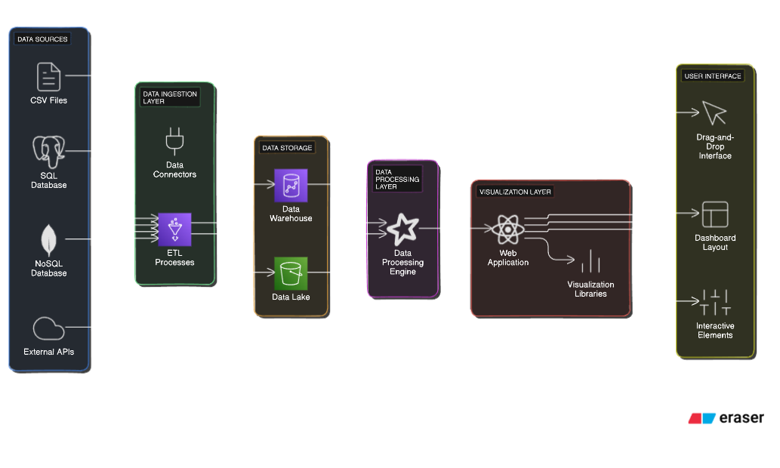database schema.

You can include an Architecture diagram in the section where you discuss the data model or database design.

**Use Cases:**

1. **Create Visualization**
   * Description: A user creates a new visualization based on their data.
   * Actors: Data Analyst, Business User
   * Pre-conditions: User has access to data sources and visualization tools.
   * Post-conditions: A new visualization is created and added to the dashboard.
   * Basic flow:
     + User selects a data source.
     + User chooses a visualization type (e.g., bar chart, line chart, pie chart).
     + User configures the visualization settings (axes, labels, data fields).
     + User adds the visualization to the dashboard.
2. **Explore Visualization**
   * Description: A user interacts with a visualization to gain insights from the data.
   * Actors: Data Analyst, Business User
   * Pre-conditions: A visualization exists on the dashboard.
   * Post-conditions: User gains insights from the data.
   * Basic flow:
     + User selects a visualization on the dashboard.
     + User interacts with the visualization (e.g., hovers over data points, zooms in/out).
     + User filters or sorts the data within the visualization.
     + User drills down into specific data points.
3. **Share Visualization**
   * Description: A user shares a visualization with other users.
   * Actors: Data Analyst, Business User
   * Pre-conditions: A visualization exists on the dashboard.
   * Post-conditions: The visualization is shared with other users.
   * Basic flow:
     + User selects a visualization on the dashboard.
     + User chooses a sharing option (e.g., email, link).
     + User provides recipient information or generates a shareable link.
     + System sends the visualization to the recipient(s).
4. **Manage Dashboard**
   * Description: An administrator manages the dashboard settings and user permissions.
   * Actors: Administrator
   * Pre-conditions: Administrator has access to dashboard settings.
   * Post-conditions: Dashboard settings and user permissions are updated.
   * Basic flow:
     + Administrator logs into the dashboard.
     + Administrator accesses dashboard settings.
     + Administrator modifies settings (e.g., layout, theme, data sources).
     + Administrator manages user permissions (e.g., adds/removes users, assigns roles).
5. **Integrate Data Source**
   * Description: An administrator connects a new data source to the dashboard.
   * Actors: Administrator
   * Pre-conditions: Administrator has access to data source configuration.
   * Post-conditions: A new data source is integrated into the dashboard.
   * Basic flow:
     + Administrator accesses data source configuration.
     + Administrator provides data source connection details (e.g., database URL, credentials).
     + System tests the connection and integrates the data source.

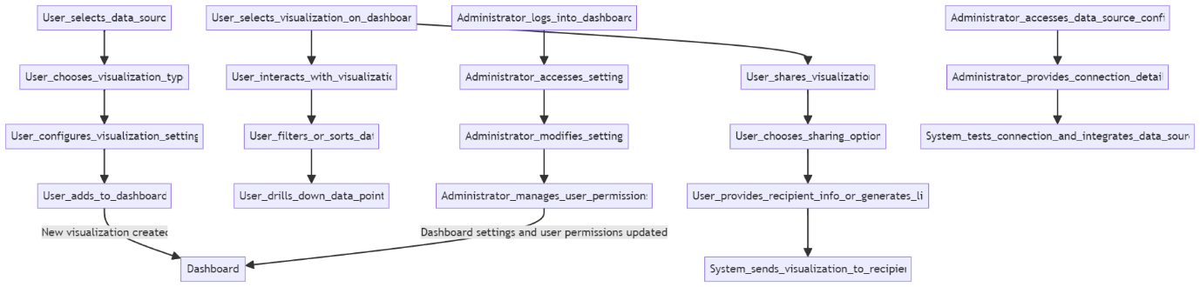

**Class Diagram:**

This class diagram captures the main components of the Vizpro and their interactions. You can expand it further by adding more detailed relationships or functionality as the design evolves.

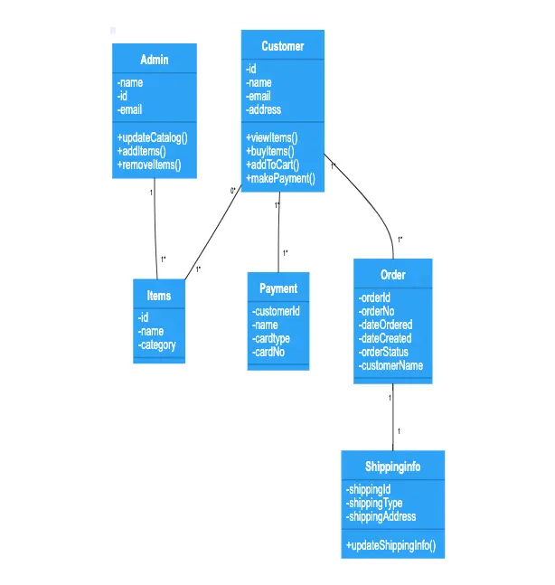

**8 Data Flow Diagrams (DFDs) at Different Levels:**

* Level 0 DFD provides an overview of the entire system, showing major processes and external entities



* Level 1 DFDs break down the processes from Level 0 into more detailed subprocesses.

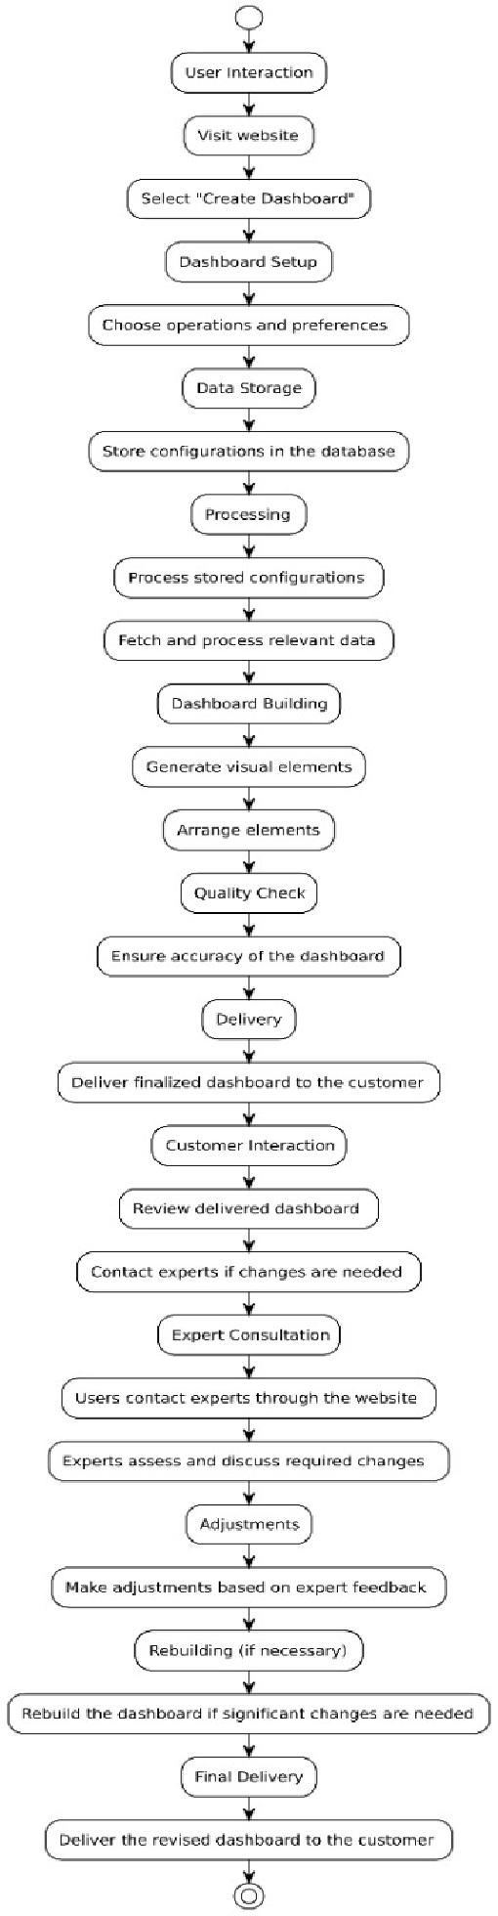

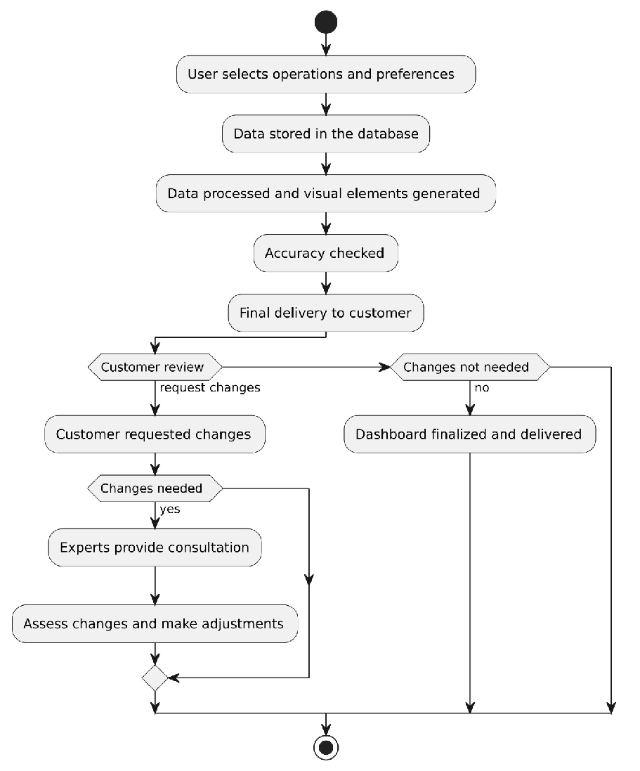

**Level 2 DFDs further detail the processes from Level 1.**

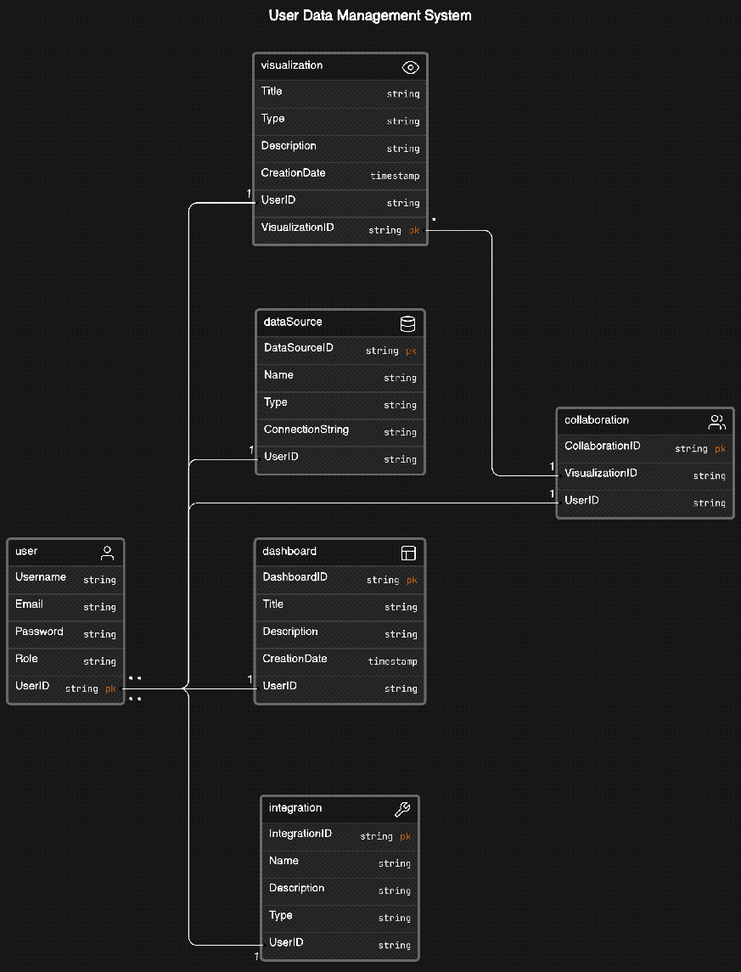

**.**

**Vizpro App:**

The Vizpro App transforms complex numerical data into easy-to-understand visualizations in real-time. Users can input data and instantly generate charts and graphs, making it easier to analyse and act on the information while on the go.

**Technology Stack:**

* **Front-end:** The app's user interface (UI) will be designed using modern frameworks like React or Flutter for a smooth and interactive user experience across both mobile and desktop platforms.
* **Back-end:** The data processing and visualization will be powered by a back-end framework like Node.js or Django, which can handle user requests and fetch data for visualization.
* **Data Visualization Libraries:** Libraries like D3.js, Chart.js, or Polly will be used to create dynamic charts and graphs from the input data. These libraries enable highly customizable visual outputs that can handle real-time data.
* **Machine Learning and AI Integration:** The app will leverage machine learning algorithms (using frameworks like TensorFlow or scikit-learn) to detect patterns in data and generate actionable insights.
* **Cloud Infrastructure:** A cloud provider like AWS or Google Cloud will host the app and store user data, ensuring scalability and real-time performance.
* **APIs:** Open data APIs or custom-built APIs will be integrated to allow users to pull in external datasets for analysis and visualization.



**Core Features:**

* **Real-Time Data Input:** Users will be able to manually input or import data directly into the app.
* **Automated Visualizations:** The app will instantly generate graphs, charts, and other visual representations of the data, helping users interpret complex datasets.
* **Data Customization:** Users can customize the way data is presented, selecting different chart types, colours, and formats**.**
* **Interactive Features:** The app will allow users to interact with the charts (e.g., zooming in on specific data points, filtering data sets) for more in-depth analysis.

**• Simplifying Data Analysis:**

* The Vizpro App is built to make data accessible to all users, regardless of their technical background. Instead of manually creating graphs or using complicated software, users can simply input data and instantly receive meaningful visualizations.
* This simplifies the decision-making process, allowing users to focus on the insights provided rather than spending time interpreting raw data.

**• Real-Time Insights:**

* For businesses and professionals who rely on real-time data for decision-making, this app will be highly beneficial. Users can monitor their data continuously and get updated visual insights as soon as new data is available.
* This real-time capability will support industries like retail, finance, or manufacturing, where timely decisions are crucial.

**• Improving Decision-Making:**

* By offering clear, actionable insights through visual representations, the app reduces the cognitive load on users, allowing them to understand trends and patterns in their data without needing to analyse the raw numbers manually.
* It will help users identify potential opportunities or risks by showcasing data trends more clearly, thereby aiding better strategic planning.

**Vizpro Chrome Extension:**

**Technology Stack**:

* **JavaScript/TypeScript**: The core logic of the Chrome extension will be developed using **JavaScript** or **TypeScript**. This will handle user interactions, data collection, and communication with the back-end.
* **Chrome APIs**: The extension will utilize various **Chrome Extension APIs** like the tabs, storage, and alarms APIs. These will allow the extension to track browser activity, store data locally, and trigger notifications or updates for users.
* **Back-End Server**: The extension can sync data with a back-end server using **Node.js** or **Firebase**, allowing users to save and access their online activity across multiple devices.
* **Front-End UI**: A minimal UI for the extension (popup window, options page) will be built using **HTML, CSS,** and **React.js** to provide users with access to their stats, settings, and productivity insights.
* **Data Storage**: The extension will store activity data locally on the browser using **Chrome’s local storage API** or sync with a cloud service like **Firebase** for users who want to store their data across devices.

**Why We Are Making It:**

1. **Growing Need for Productivity Tools:**
   * **With remote work and online tasks becoming more common, people need tools that help them stay productive. This Chrome extension is designed to fill that gap by helping users manage their time effectively and eliminate digital distractions.**
   * **As many professionals spend a significant portion of their day in a web browser, tracking their usage becomes essential for better time management.**
2. **Combating Digital Overload:**
   * **The average user is exposed to constant online distractions like social media, news sites, and entertainment platforms. This extension will help users regain control over their online habits by showing them how they spend their time.**
   * **By helping users track and limit non-productive browsing, it promotes healthier digital habits and helps users combat digital overload.**
3. **Improving Work Efficiency:**
   * **For professionals and students alike, optimizing how they use their browser can lead to significant improvements in work efficiency. The extension offers insights into time spent on research, communication, or non-work-related activities, allowing users to identify where time can be better spent.**
4. **Business Application:**
   * **In a business environment, the extension can be particularly useful for teams or managers who want to analyse productivity patterns without being invasive. It helps employees be more aware of their work habits, leading to better performance.**
5. **Market Demand for Self-Improvement Tools:**
   * **There is an increasing market demand for personal productivity and self-improvement tools. By launching this Chrome extension, we aim to meet that demand and provide users with a tool that improves both their professional and personal lives through data-driven insights.**

**9 Website Overview:**

* **Provide a high-level overview of the website's design, including its layout, navigation structure, and key features.**
* **You can include wireframes or mock-ups to visually represent the website design.**
* **Describe the user interface elements, such as buttons, forms, menus, etc.**
* **Mention any specific design considerations, such as responsiveness for different devices.**
* **This overview can be included in the section discussing user interfaces or system design.**

**Website:** [**Vizpro**](https://github-cyrus.github.io/VizPro/)

**The provided link directs to a GitHub Pages website for a project named Vizpro. As it's a public GitHub Pages site, I can provide an overview of what seems to be presented based on the content available.**

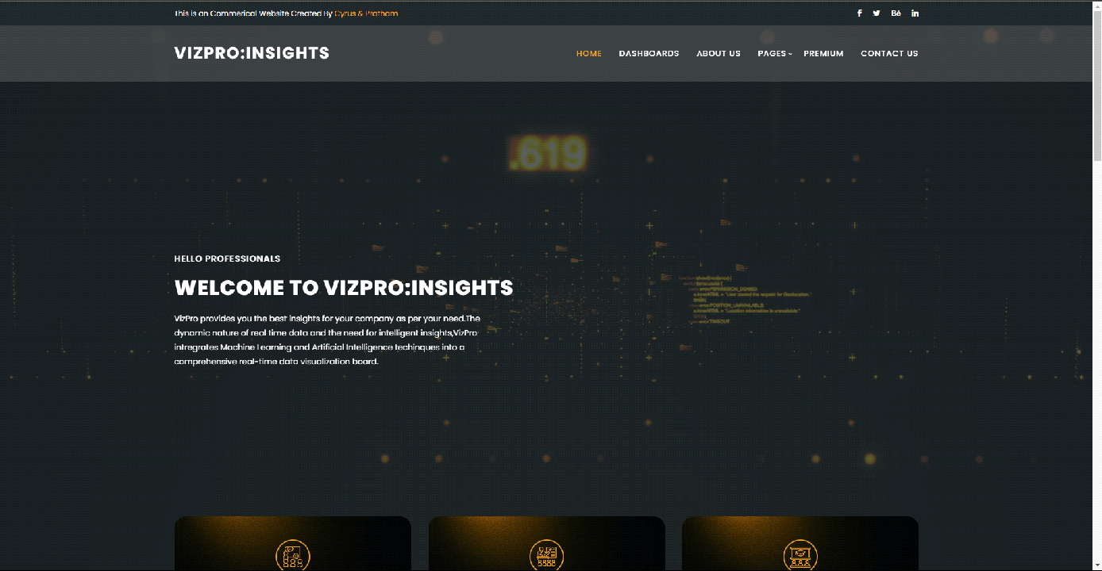

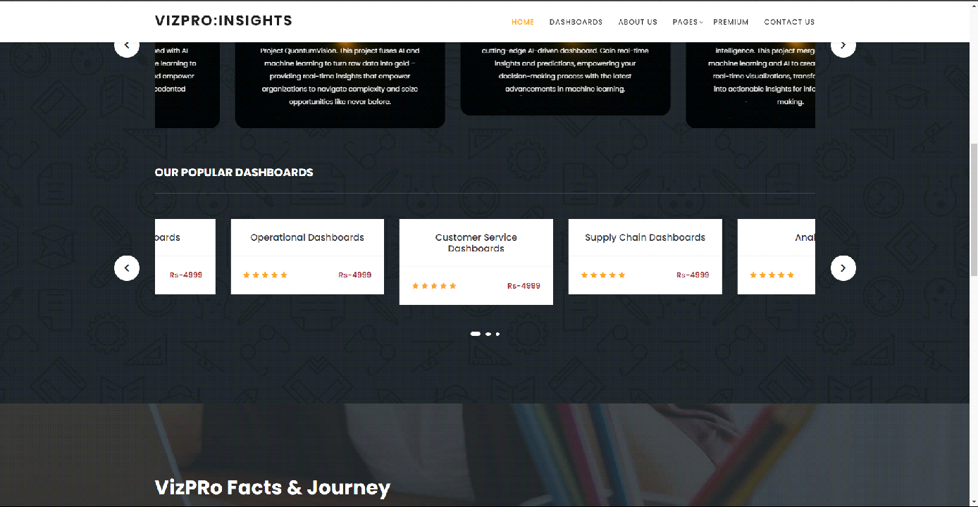

**This section likely highlights the key features and functionalities of Vizpro, showcasing its capabilities in data visualization and analysis.**

**It may include descriptions, screenshots, or demos demonstrating the various visualization tools and customization options available.**

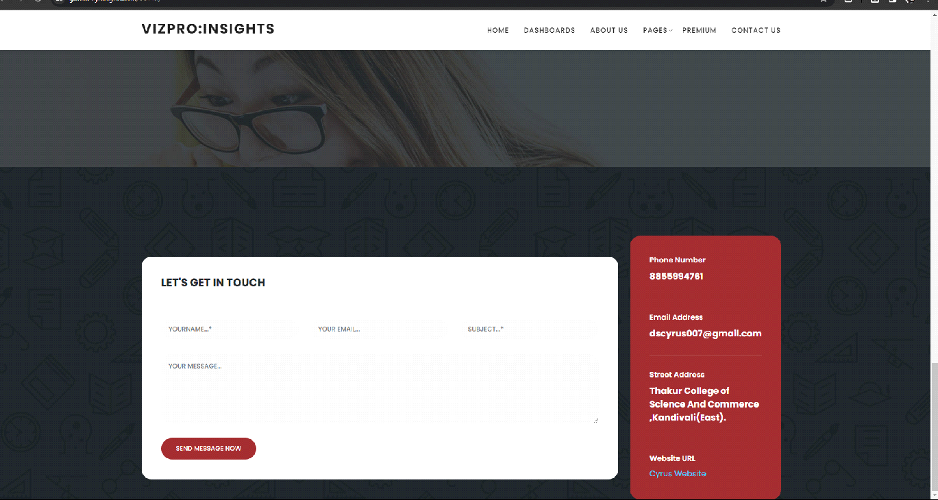

**Visitors may have the option to contact the project maintainers for support, feedback, or collaboration opportunities.**

**This section may include contact forms, email addresses, or links to communication channels such as GitHub issues or discussion forums.**

**Overall, the website appears to serve as a platform for showcasing Vizpro, providing information, documentation, and possibly interactive demos to users interested in exploring its features and functionalities.**

**10 Partial Implementation with Website Overview**

For the partial implementation of Vizpro, we will focus on developing a functional website that serves as the interface for accessing and interacting with the data visualization dashboard. This partial implementation will provide a solid foundation for further development while delivering key functionalities to users. Below is an overview of the planned website implementation:

**1. Frontend Development:**

We will prioritize frontend development to create an intuitive and user-friendly interface for users to interact with the Vizpro dashboard.

Utilizing modern web technologies such as HTML5, CSS3, and JavaScript frameworks like React.js or Vue.js, we aim to develop a responsive and visually appealing website.

The frontend will include features for:

**2. Backend Development:**

While the focus will be on frontend development for this partial implementation, we will also implement basic backend functionalities to support essential features of the website.

The backend will include functionalities for:

User management, including registration, login, and profile management.

Integration with data sources to fetch and store data for visualization.

Basic data processing capabilities to support visualization creation and interaction.

**3. Database Setup:**

For this partial implementation, we will use a lightweight database solution such as SQLite or MongoDB to store user data, authentication credentials, and basic configuration settings.

The database schema will be designed to support user management, session handling, and basic data storage for visualization purposes.

**4. Deployment Strategy:**

Initially, the website will be deployed on a development server environment for testing and evaluation.

**5. Iterative Development Approach:**

By implementing the Vizpro dashboard as a website with the outlined features and development approach, we aim to deliver a functional and user-friendly platform for data visualization and analysis. This partial implementation will lay the groundwork for future enhancements and expansions as we continue to develop and refine the Vizpro software.

**11 Sign-off**

This Software Requirements Specification is hereby approved by the stakeholders involved in the development and is subject to change with the agreement of all parties involved.

Stakeholder Signatures:

[Signature spaces for key stakeholders]

---

This document serves as a foundation for the development of Vizpro, ensuring clarity and alignment among all parties involved in its creation and use.